# Setting Up AWS Services for Quaefacta Web Application:

## VPC and subnets

## Graphical user interface, text, application Description automatically generatedEC2 Instance

Then create a new key pair / assign to an already existing key pair u have access to

Make sure to select the VPC you created and select the public subnet.

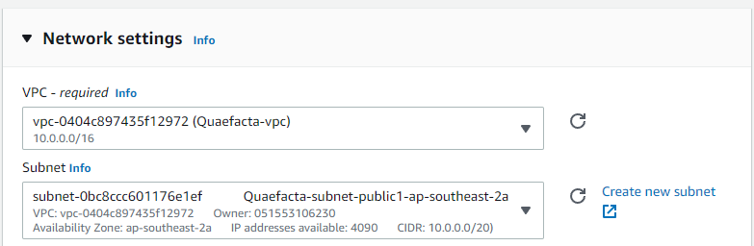

Then create a security group, making sure that you open ssh, HTTP and HTTPS inbound access

## RDS

Its really important to select General Purpose SSD as IOPS will cost $300 more per month

## Aws S3 bucket

